Readings & Assignments: Week 2
Week 2 Readings
Complete the following readings early in the week:
- Week 2 online lectures
- From 3ds Max Help file, read the following topics:
  - Unwrap UVW Modifier
  - Edit UVWs Dialog
  - Unwrap Options Dialog
  - Pack UVs Dialog
  - Render UVs Dialog
While reading, make note of pertinent and important facts. You will be required to reference your readings in discussions and apply them in this week’s assignments.
Week 2 Assignments Overview
Assignment Summary: Week 2 | Due Date
Assignment 1: Discussion Questions | Saturday, February 27, 2010
Assignment 2: Creating a Gun Turret | Sunday, February 28, 2010
Assignment 3: Creating and Applying a Texture | Sunday, February 28, 2010
Assignment 4: Final Project | Monday, March 1, 2010

Week 2 Overview
In Week 1, you learned about unwrapping three-dimensional (3D) meshes using the Unwrap UVW modifier.
As 3D meshes become more complex, their mapping coordinates and unwrapping process also become more complex.
This week, you will expand on the concepts of the Unwrap UVW modifier and learn about some of the parameters of the modifier that help in the complex unwrapping process. These parameters help in minimizing the number of mapping clusters, seams, and distortions. For example, the Edit UVWs interface, which is a parameter of the Unwrap UVW modifier, enables you to view how the UV coordinates of the meshes are being manipulated. This, in turn, helps you update the solutions as and when they are created in different viewports to ensure that you modify the meshes as required. In the Edit UWVs window, under Viewport Options, select the Constant Update option to view the changes in real time in the different viewports. This will help you see how the UV adjustments affect the mesh.
Let's now learn in detail about the Edit UVWs parameter that makes the complex process of unwrapping simpler with the help of its interface tools and options.

Learning Outcomes
- Create complex material and UVW mapping solutions. Apply specific UVW mapping coordinates to simple and complex models.
- Demonstrate the ability to apply basic material to 3D models.

Unwrap UVW: Welding
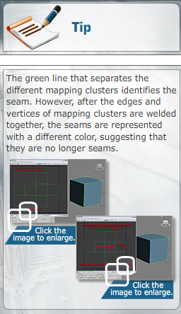
Each polygon used to create a mesh in 3ds Max can have its own individual mapping coordinates. Manipulating the mapping coordinates of each polygon in a mesh creates an extremely complex mapping solution, making it difficult to create a custom texture and creating a large number of mapping seams.
To make the process simpler, it is advisable to create mapping clusters out of different polygon selections. This minimizes the number of UV pieces and seams. After the mapping clusters are created from multiple polygons facing a similar direction, the mapping clusters can be combined with other mapping clusters to further minimize the number of seams.
To create mapping clusters with a fewer number of seams, a welding process is used. The welding process makes use of the Weld Selected and Target Weld tools in the Edit UVWs interface to combine the edges and vertices of different mapping clusters. Once the vertices are welded or the edges stitched, the seam is removed and the two sides become one. The welding tools enable the user to use vertices and edges as locators to determine how the other mapping clusters can be connected. All vertices can be set to show vertex connection, which is a display option that identifies all shared vertices with the same number. Vertices that have the same number, when selected, share the same edge and can be welded together using either the Weld Selected or Target Weld tool.
When the mapping solution of an object is simplified, the number of seams is minimized and stretching is fixed. Then, the mapping clusters need to be arranged or packed to fit into the mapping or texture space provided in the Edit UVWs window. This is done by a process called packing.
In the next lecture, you will learn about packing and arranging UVW mapping clusters.

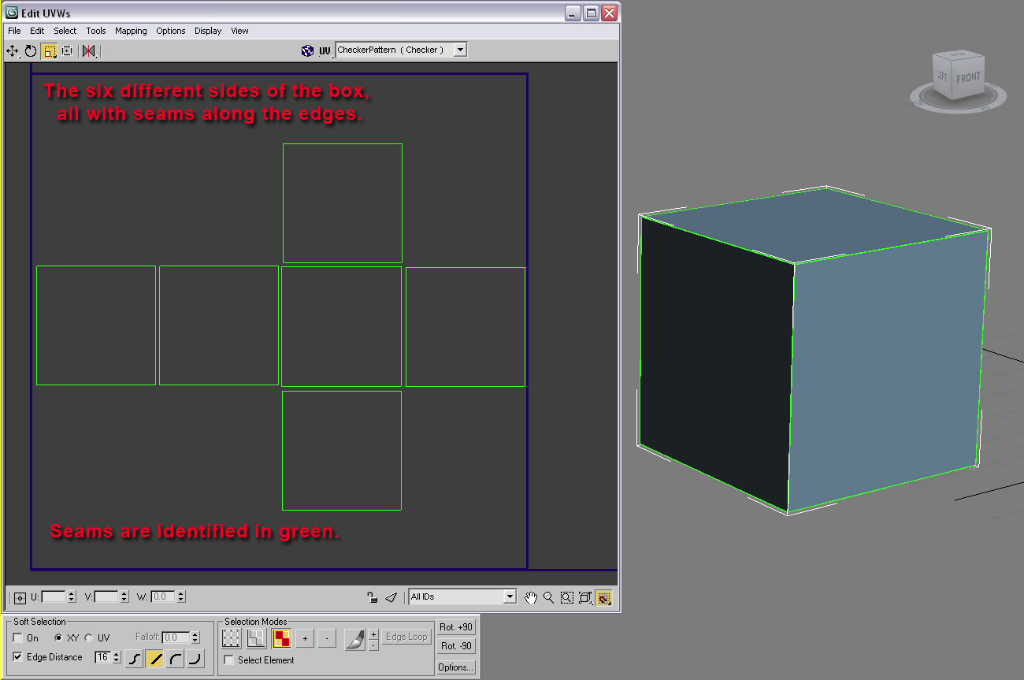
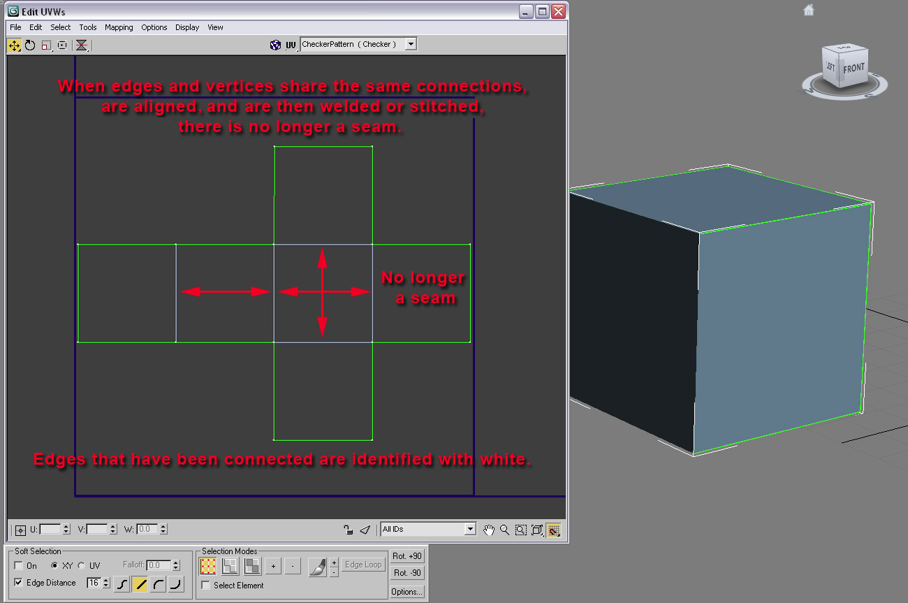

Welding

Welding enables a user to attach different mapping coordinates to create a mapping cluster.
Combining UVW clusters requires you to identify the clusters and their edges and vertices to ensure
correct alignment. Once the clusters are positioned and the edges and vertices are identified, you weld
them together to form a new cluster.

The Six Sides of a Cube’s UVW Mapping Coordinates

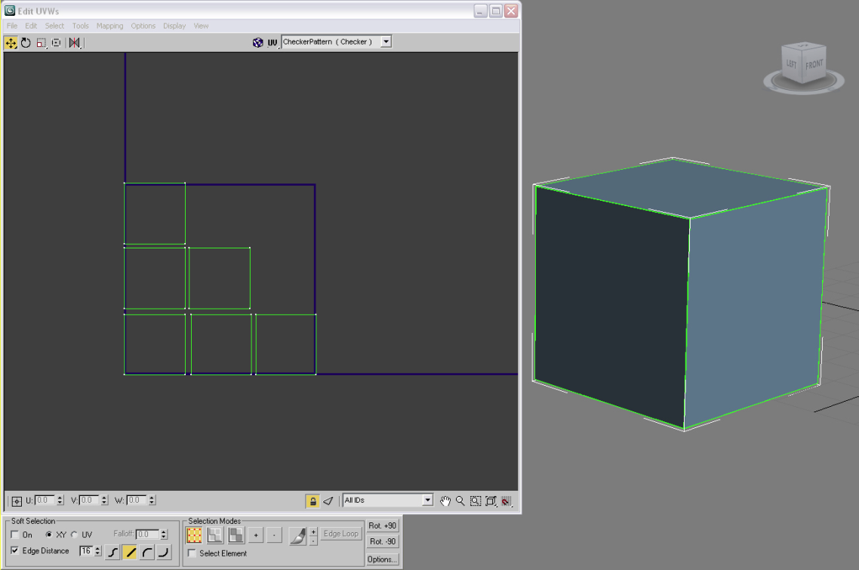

1. Identify the different UVW mapping coordinates.

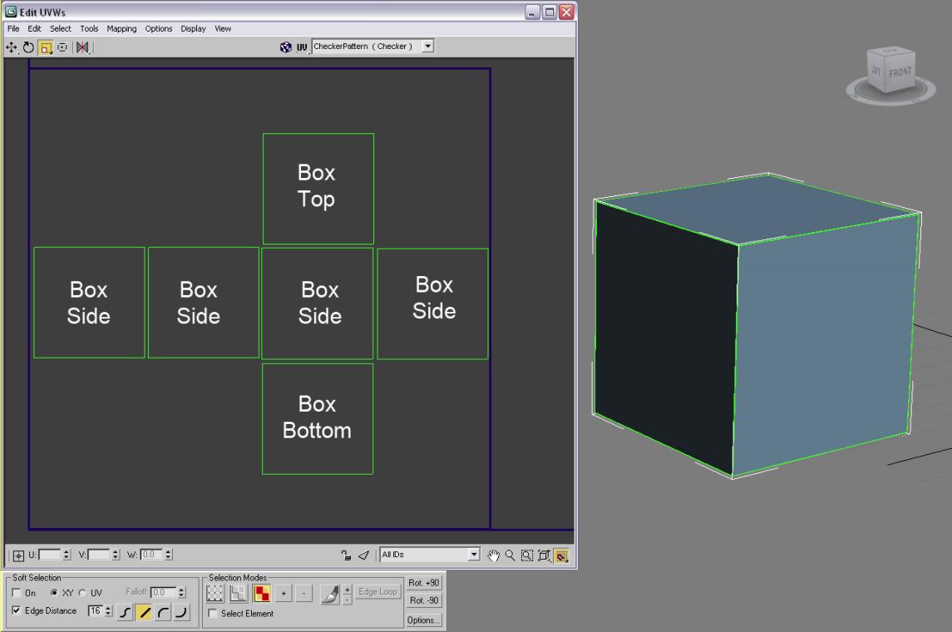

2. Identify the edges to make sure that the corresponding edge is aligned.
The red edges are selected and the Edit UVWs window automatically highlights the
corresponding edge in blue.
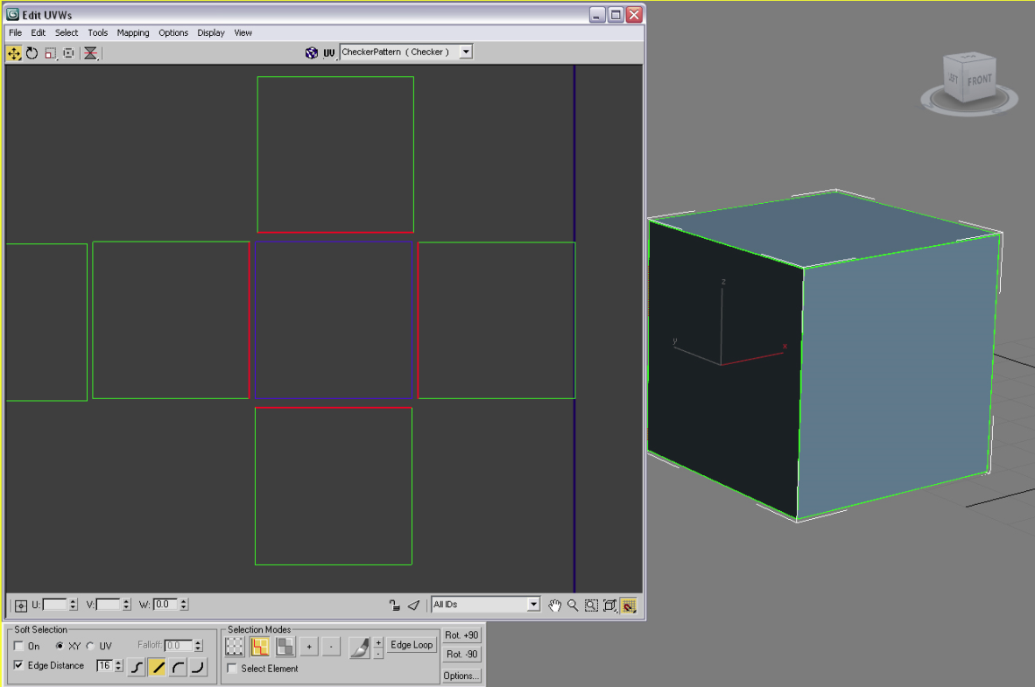
3. Make sure the vertices are aligned to their corresponding vertices.

The selected vertices are in red, and their corresponding vertices are automatically highlighted in
blue.

If you turn on the show vertex connection, the selected vertices and their corresponding
vertices become numbered. This ensures that you weld the correct vertices.
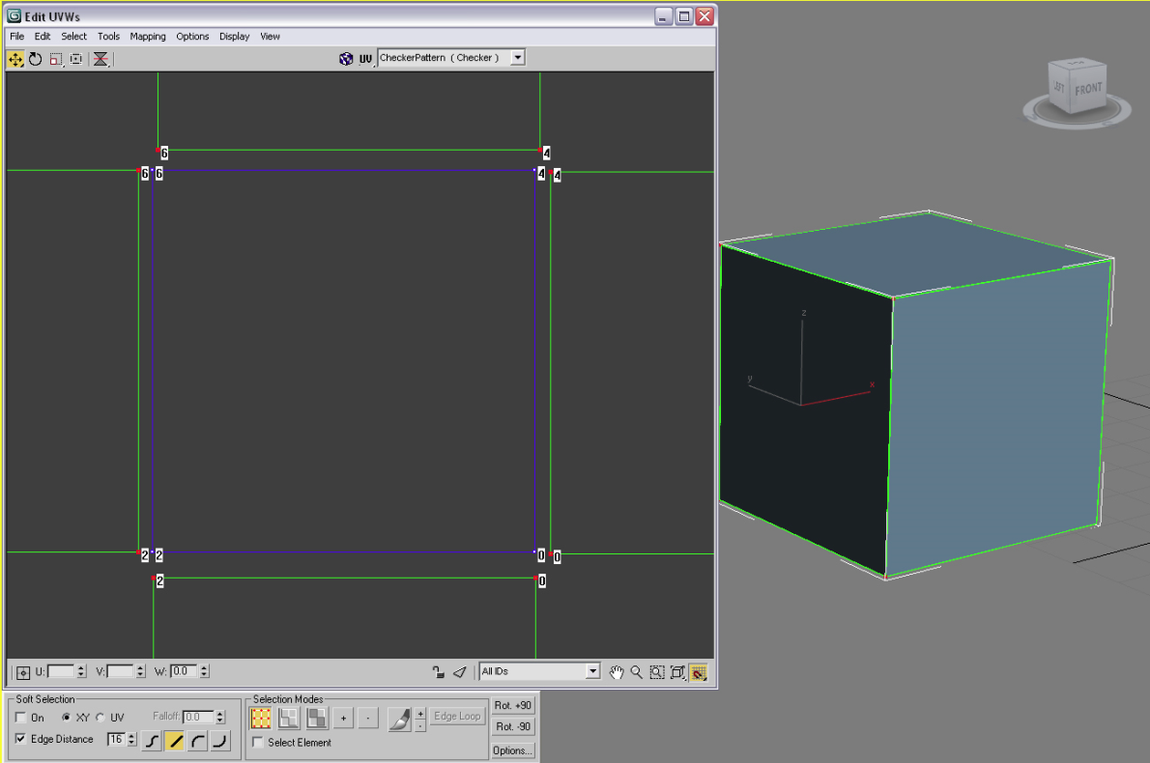

4. Use the Tool menu to choose either a Weld Selected or a Target Weld to connect corresponding
vertices.
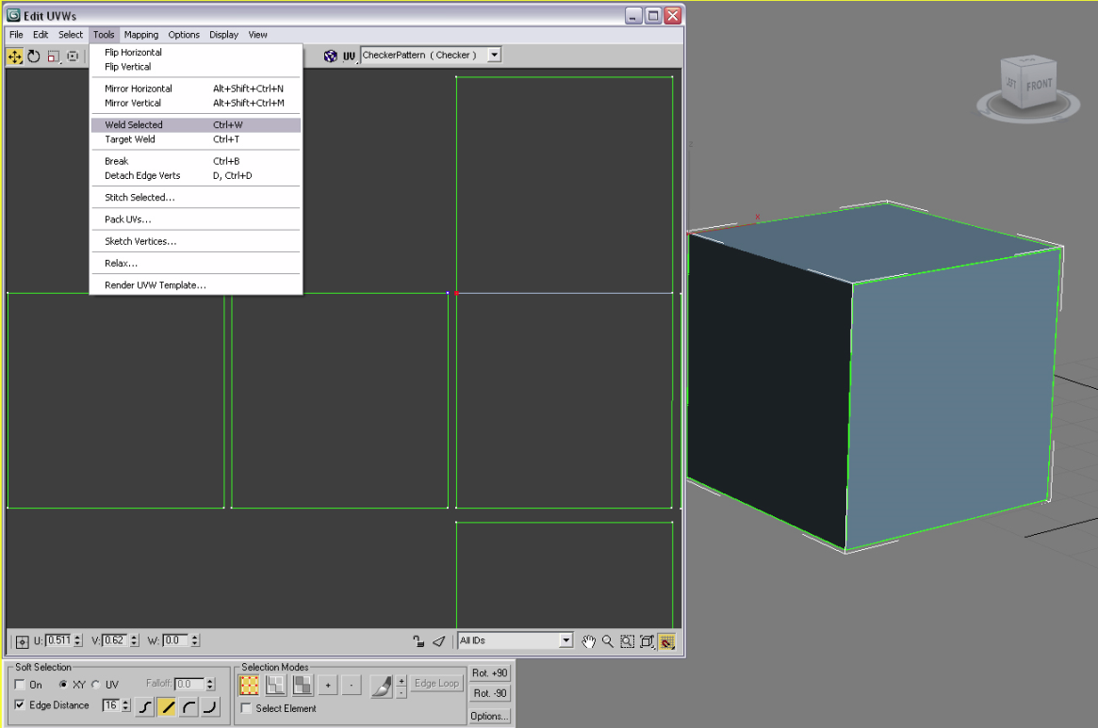

5. Once the two vertices lying on the same edge are welded, that edge turns white, which identifies a
seamless transition from one section to the next.

The color green identifies the seams, or the separation or gaps between mapping clusters.
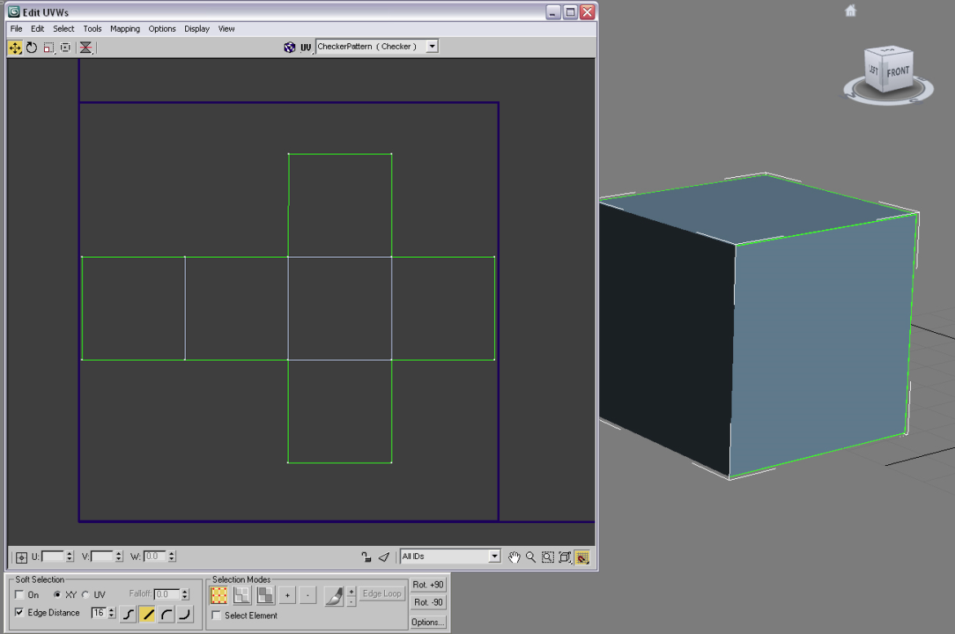

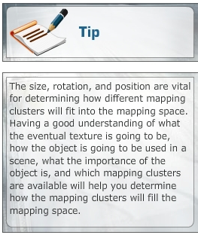
Packing Mapping Clusters
You should never waste texture space. By maximizing the use of texture space, you create more room in the texture to create custom designs in the
two-dimensional (2D) paint application. If the space is wasted, you are limiting the amount of room you have to paint within the mapping solution. Before starting the packing UVW process, you should know the end result of the 3D mesh being unwrapped. This information is essential in the arrangement and transformation of the different mapping clusters.
The square mapping space in the Edit UVWs window is identified with a thick navy blue line. The mapping space line and the mapping clusters can be difficult to view; therefore, using the Options menu or Preferences and adjusting the colors that the Edit UVWs dialog window uses can help you identify how different options are displayed when you are working in the Edit UVWs window. In the Color options, you can toggle off the grid and change the colors of shared subobjects to help you view information in the Edit UVWs window. The checkered pattern is a default map that can be toggled on and off to get a better view of the mapping coordinates in the Edit UVWs window.
Using the basic transformation tools such as move, rotate, and scale, you can manually arrange the mapping coordinates in the texture space to have a better understanding of where and how the mapping coordinates will be affected once exported from the Edit UVWs window to any 2D paint application.
However, packing mapping clusters into mapping space manually increases the time required to create a mapping solution. 3ds Max provides a tool that can assist users in the packing phase of the unwrapping process. The Pack UVs tool is used to arrange different mapping clusters based on how each one of them has been manipulated. This means that based on the way mapping coordinates have been assigned to polygons, the 3ds Max software calculates the best fit for those mapping clusters into the mapping space.
After creating the best possible mapping solution for a mesh by minimizing seams, clusters, and distortions, it is time to use the solution to create a custom texture. The texture gives 3D mesh its distinct characteristics. For example, if you model a 3D character with specific characteristics, you would create the mapping solution, export that UVW template to a paint application, and create those characteristics by painting the texture.
Creating a custom texture by painting, using a photo reference, or using another method is one of the main reasons for unwrapping.
In the next lecture, you will learn in detail how custom textures are created in 3ds Max.

Packing Mapping Clusters
Packing enables a user to arrange UVW mapping clusters into the mapping space.
Once you identify the mapping clusters, weld the clusters, and minimize stretching and distortion, you
have to “pack” your UVs into the mapping space.
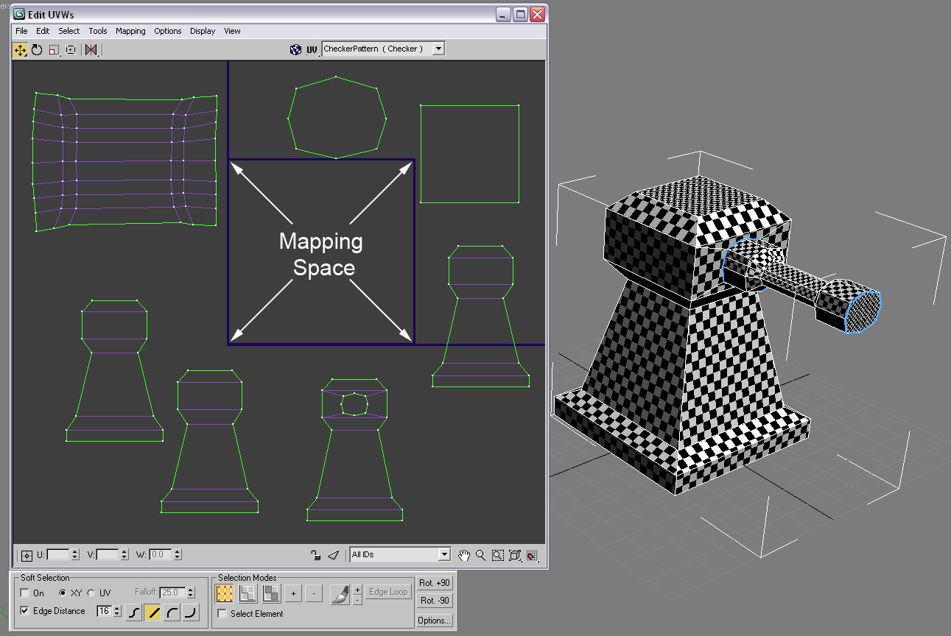

1. On the Tool menu, use the Pack UVs tool, this will enable the software to use the different mapping
clusters, that exist in the Edit UVWs window, and place them into the mapping space.
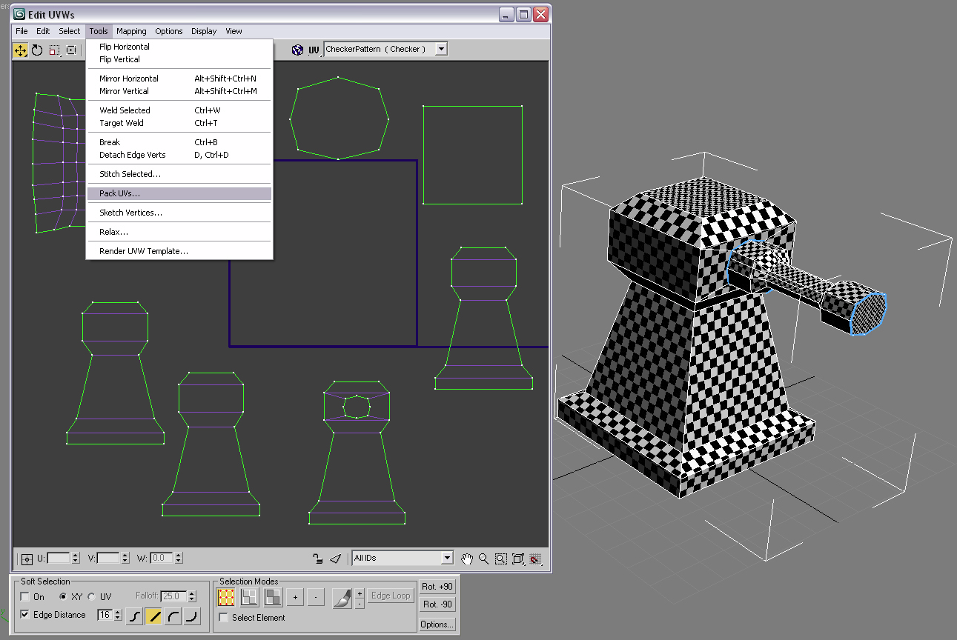
2. The computer arranges the mapping clusters based on the Pack UVs options, which can result in an
undesirable arrangement.
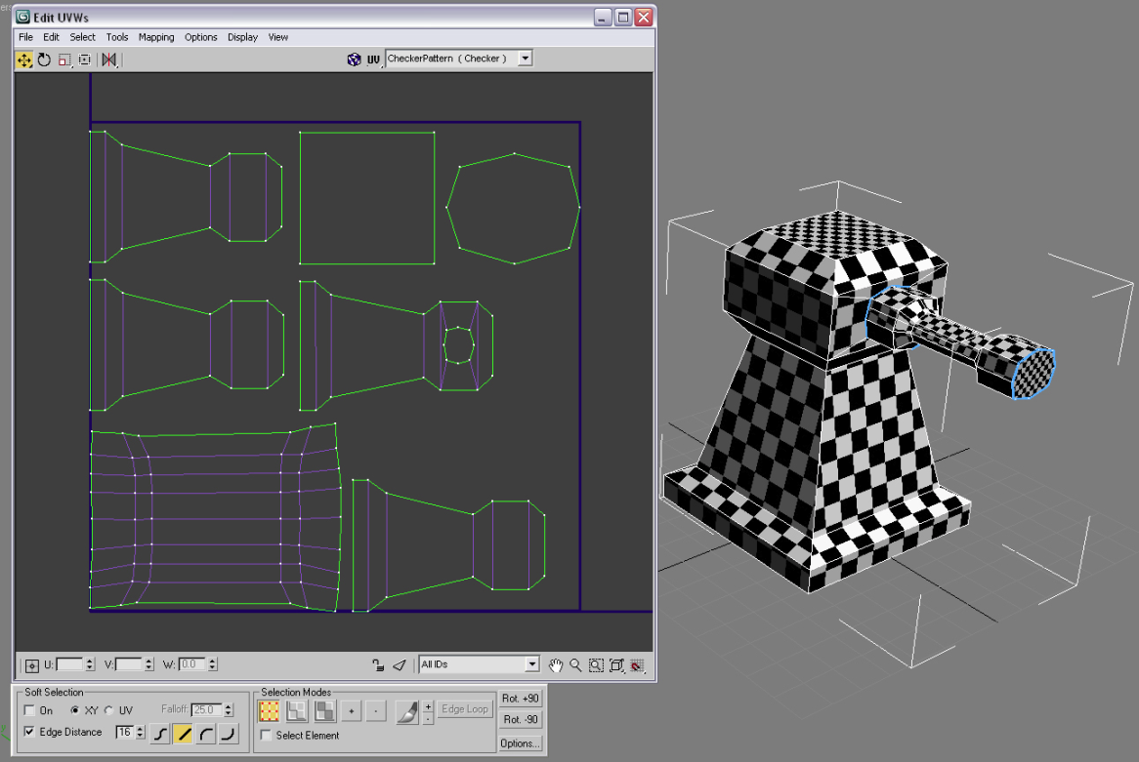

3. When packing UVs into the mapping space, it is sometimes best to manually transform the mapping
clusters and place them in the desired arrangement. This gives you more control over where and how the
different mapping clusters are placed.

These options for the final layout of the UVW mapping coordinates were done manually, without
applying the Pack UVs tool option. Depending on the object, the number of clusters, and the final
look of the 3D mesh, your layouts will vary.
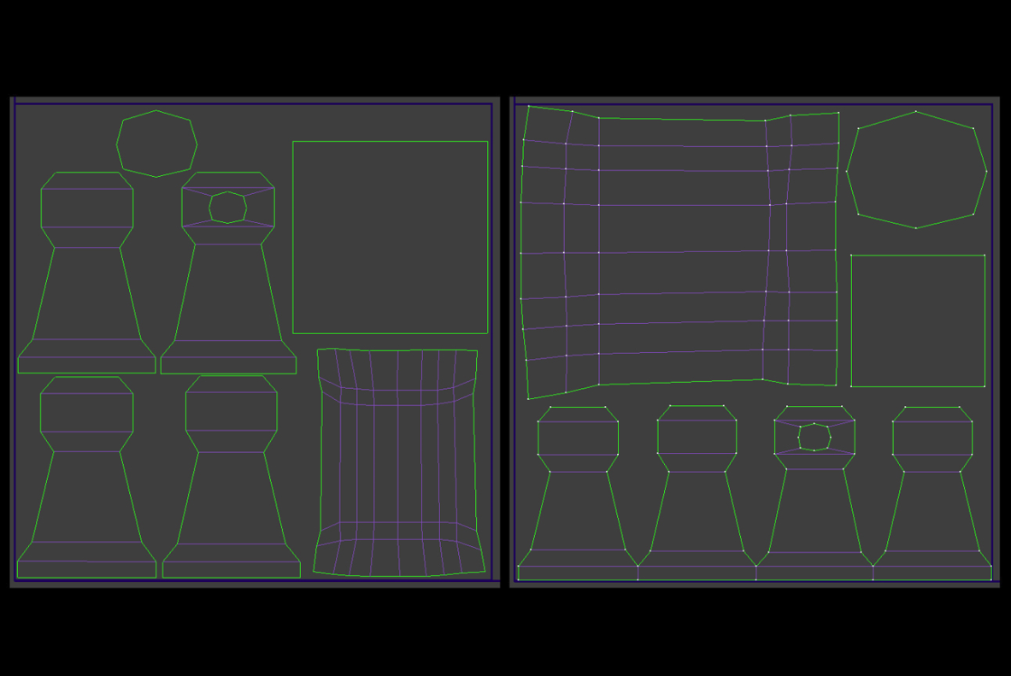

Rendering UV Templates
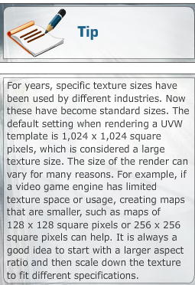
To create a custom texture of an object, its UVW mapping coordinates need to be exported to a 2D paint program. This is done by rendering the mapping coordinates and saving that template as a bitmap image. This bitmap image is then used in a 2D paint application to create a custom texture.
Rendering UVW mapping coordinates and creating a bitmap image template involve the Edit UVWs window. In the Edit UVWs window, a user can export UV coordinates. The Tools menu of the Edit UVWs window offers the Render UVW Template tool, which enables the user to take a screen shot by rendering the Edit UVWs window and then saving it as a bitmap (pixel) image. The rendered-out mapping solution can be saved with a variety of different file extensions, depending on what you want. The Render UVW Template option enables a user to specify different options, which allows the user to view the map cluster after it is rendered. Two important options while rendering the UV template are the aspect ratio and the pixel size, in which the mapping coordinates need to be saved before you can work on them in a 2D paint program.
Textures are usually created as square pixel bitmap images, where the height and width are even. This is also how the mapping space in the Edit UVWs window is displayed. The default size is 256 x 256 square pixels.
This brings us to the end of this week's lecture. Let's summarize the key learning from the week.

Summary
This week, you learned about the Unwrap UVW modifier and the way its tools, parameters, and options enable a user to simplify the unwrapping process.
You learned how the Edit UVWs window enables a user to view the UVW coordinates. You also learned how the Constant Update option is used to synchronize UVW coordinates with viewports. This helps you to see how a mesh is affected by different transformations and how the seams are controlled.
Next, you learned that the Edit UVWs window has mapping space in which all the different clusters are arranged and organized.
This week, you were also introduced to the concept that the exported UVW template that houses the different mapping clusters is used as a blueprint to create a custom texture in a 2D paint application. In addition, you discussed that making sure the rendered template has been saved with the proper aspect ratio, which can be modified on the basis of different scenarios, enables you to have a more detailed texture and space to work with.
Next week, you will be introduced to animation and how to prepare a scene for an animation. You will also discuss different principles, techniques, and tools that can be used to animate a 3D object.

Assignment 1: Discussion Questions
By Saturday, February 27, 2010, respond to the discussion questions assigned to you by the facilitator. Submit your responses to the appropriate Discussion Area. Start reviewing and responding to your peers’ posts as early in the week as possible. You can ask a question, post a comment, or add a point to expand the discussion. Be honest, clear, and concise.
Always use constructive language, even in criticism, to work toward the goal of positive progress. Make sure to use your course text or other research when possible in your responses.
Support your statements with appropriate references wherever necessary. Follow current MLA guidelines for writing style, spelling, grammar, and citation of sources.
Assignment 1 Grading Criteria | Maximum Points
Response Criteria:
Met the criteria for the correct responses to the questions assigned. | 4
Used vocabulary relevant to the current and previous weeks' topics—at least five terms. | 4
Participation Criteria:
Used vocabulary relevant to the current and previous weeks' topics—at least five terms. | 4
Participated in the discussion by asking a question, providing a statement of clarification, providing a point of view with a rationale, challenging a point of discussion, or making a relationship between two or more points of the discussion. | 4
Justified ideas and responses by using appropriate examples and references from textbooks, Web sites, and other references or personal experience. | 4
Total: | 20
For assistance with any problems you may have when completing this assignment—OR—to offer your assistance to classmates, please use the Problems and Solutions Discussion area located through the left side navigation link.
This week work on questions 2 and 4. These will cover the issue of texture seams and the importance of the UV Templates.
Post your answers here and comment on the work of at least two of your peers.

DQ 1
When unwrapping a complex model, what are some of the different ways you can approach the task of unwrapping? What are some of the things you would consider before beginning to unwrap? Why? Justify your answers using appropriate rationale and examples.
DQ 2
What are texture seams? Do you think they are important to consider when unwrapping a model? Why or why not? What do texture seams represent on the mapping coordinates?
DQ 3
What can you do to the different mapping clusters of a model to simplify and minimize them? Share an example to explain how you can reduce mapping clusters and the benefit it confers.
DQ 4
For what reasons would you want to export an unwrap? Describe at least two scenarios in which you would choose to do so. What are some of the important things to consider when getting an unwrap ready for exporting? Why? Justify your answers with appropriate examples and rationale.

Assignment 2: Creating a Gun Turret
A gun turret is a device that provides a mechanism for using a projectile firing weapon. It lets the weapon be aimed and fired in many directions. The turret provides a rotating weapon platform. In this assignment, you will create a gun turret using the techniques you have learned so far.
Perform the following:
- Create a gun turret using box or poly modeling techniques and parameters found in the editable poly or editable mesh modifier.
- Apply mapping coordinates to the gun turret, and make sure that seams and stretching are minimized.
- Organize the mapping clusters, utilize the texture space efficiently, and export a UVW template to be used in a 2D paint application.
- Create a 640 x 480 render of the gun turret from the perspective view, with the checker material assigned. Leave the default lighting on when rendering, and make sure that the gun turret is in the three-fourth view with the barrel of the gun visible. Change the color of the background to enhance the view of the gun turret with the checker material, making the black-and-white checker pattern more visible. Use your creativity to enhance the gun turret.
- Save the render as W2_A2_LastName_FirstName_Screenshot.jpeg.
- Export the UVW Template as a 1,024 x 1,024 texture and save it as W2_A2_LastName_FirstName_UVWTemplate.jpeg. You will use this template in the next assignment.
- Submit both the render and the UVW template to this Discussion Area by Sunday, February 28, 2010.
Discussion
By the end of the week, use this Discussion Area to discuss the following:
- How did the knowledge about UVW mapping coordinates and their working affect the creation of the model?
- What were some of the things you thought about when packing the UVW mapping clusters? How were the clusters arranged?
Critique Exercise
By the end of the week, use this Discussion Area to review and comment on the assignments posted by at least two of your peers. Comment on:
- Screenshot: Does the model have the style of a gun turret and follow proper typology and rendering requirements as listed in the assignment instructions?
- UVW Template: Have the seams and stretching been minimized while retaining the shape of the gun turret? Have the UVW clusters been efficiently arranged, transformed, and packed into the texture space?
Assignment 2 Grading Criteria | Maximum Points
Created a gun turret using appropriate box or poly modeling techniques and parameters found in the editable poly or editable mesh modifier. | 10
Applied mapping coordinates to the gun turret, making sure that seams and stretching are minimized and utilized the texture space efficiently. | 10
Created a 640 x 480 render of the gun turret with proper render requirements as listed in the assignment. | 10
Exported a 1,024 x 1,024-texture UVW template to be used in a 2D paint application. | 10
Reviewed and critiqued the submissions of at least two peers on the basis of the critiquing guidelines. | 10
Total: | 50
For assistance with any problems you may have when completing this assignment—OR—to offer your assistance to classmates, please use the Problems and Solutions Discussion area located through the left side navigation link.
Read First!
This week's main assignment involves modeling and texturing a gun turret. This can be the turret on a tower or on top of a tank. It can be futuristic or realistic, cartoony or photorealistic. In all these cases what we are looking for is a clean UV template and a good texture.
Very important:
- Model an environment for the turret. Don't leave things floating in space. A ground plane or some terrain, a sky (any time of the day), and at least a basic three point light setup are necessary. Please ask if you are unsure of any of this.
- The texture, to be painted in the next assignment, must have some clear details. It is fine if you want to paint a camouflage, but also paint some clearly identifiable details such as access panels, cables or tubes running across the surface, buttons, bullet holes, scratches, and such.
For this first stage model the scene and unwrap the parts of the turret. Post your work here and comment on the work of at least two of your peers.

Assignment 3: Creating and Applying a Texture
In this assignment, you will use the UVW template rendered out of the Unwrap UVW editor of the gun turret in Adobe Photoshop. You’ll create a custom texture to be applied to the mesh (gun turret) to give it a distinct style.
Perform the following:
- Use the exported 1,024 x 1,024 square pixel UVW template in Photoshop to create a custom texture for the gun turret to give it a distinct appearance. The texture should be designed to look like a gun that has been fired and that has received some battle damage and natural weathering. Apply different markings to this effect.
- Apply the newly created map back to the gun turret model after the texture has been created. Use the material editor to enhance the map more to give the surface a specific look.
- Set up the gun turret in the perspective view to be rendered with lighting, textures, and a floor plane.
- Save the Photoshop texture (without the wireframe of the mapping coordinates) as W2_A3_LastName_FirstName_Texture.jpeg.
- Create a 640 x 480 render of the final gun turret from the perspective view and save it as W2_A3_LastName_FirstName_Gun_Turret.jpeg. Make sure to pick an angle that best suits your model. Lighting should help accent the newly applied texture and cast shadows onto the floor plane.
- Submit both the .jpeg files to this Discussion Area by
Sunday, February 28, 2010.
Discussion
By the end of the week, use this Discussion Area to discuss the following:
- How did the UVW template affect the creation of the final gun turret texture?
- How would you change the UVW mapping clusters arrangement to improve the texture painting process in Photoshop? Why would you make those changes?
Critique Exercise
By the end of the week, use this Discussion Area to review and comment on the assignments posted by at least two of your peers. Comment on the final gun turret render providing specific feedback on the following:
- How the applied texture works or does not work on the gun mode, style, and aesthetics?
- Did the use of lighting affect the render in a positive or negative way?
Assignment 3 Grading Criteria | Maximum Points
Created a 640 x 480 render of the final gun turret with appropriate light, textures, and a ground plane. | 20
Saved the gun turret texture as a 1,024 x 1,024 sq pixel .jpeg file without the wireframe of the mapping coordinates. | 10
Exported the textured map from Photoshop, applied it to the gun turret model, and used the material editor to enhance the map to give the surface a specific look. | 10
Participated in the discussion based on the discussion guidelines. | 10
Reviewed and critiqued the submissions of at least two peers on the basis of the critiquing guidelines. | 10
Total: | 60
For assistance with any problems you may have when completing this assignment—OR—to offer your assistance to classmates, please use the Problems and Solutions Discussion area located through the left side navigation link.
READ FIRST
In this second part of the assignment you will use the UV template and paint the texture for the parts of the turret, light and render the scene. Keep in mind:
- Model an environment for the turret. Don't leave things floating in space. A ground plane or some terrain, a sky (any time of the day), and at least a basic three point light setup are necessary. Please ask if you are unsure of any of this.
- The texture, to be painted in the next assignment, must have some clear details. It is fine if you want to paint a camouflage, but also paint some clearly identifiable details such as access panels, cables or tubes running across the surface, buttons, bullet holes, scratches, and such.
Post your work here and comment on the work of at least two of your peers.

Assignment 4: Final Project
Last week, you created concept designs for the vehicle and environment. This week, you’ll finish building the vehicle and environment and begin to think about textures.
Perform the following:
- Finish the modeling of the vehicle and environment. Be sure that the vehicle is under 3000 polygons and the environment is under 5000 polygons
- Render a checkboard test (using a checker material) of both the vehicle and the environment. This will be used to test the UVW Templates and texture mapping.
- Render minimum 3 wireframe images for the vehicle and 3 areas of the environment in wireframe format.
- Start to think about textures for the vehicle and environment. Think of ways that the textures can add detail to the models.
- Clean up all models and be sure they fall under the required polygon count.
- Save the modeling files as W2_A4_VehFinal_LastName_FirstName.max and W2_A4_EnvFinal_LastName_FirstName.max.
- Submit the file to this Discussion Area by Monday, March 1, 2010.
Discussion
- By the end of the week, use this Discussion Area to discuss your modeling and polygon reduction techniques.
Critique Exercise
By the end of the week, use this Discussion Area to review and comment on the assignments posted by at least two of your peers. Comment on the final scene and how it is starting to take shape. Provide specific feedback on the following:
- Do the models match the concept designs?
- What are the strong areas and areas of improvement?
Assignment 4 Grading Criteria | Maximum Points
Finished the modeling of the vehicle and environment. | 30
Rendered minimum 3 wireframe images for the vehicle and 3 areas of the environment in wireframe format. | 20
Discussed modeling and polygon reduction techniques. | 20
Reviewed and critiqued the submissions of at least two peers on the basis of the critiquing guidelines. | 10
Total: | 80
For assistance with any problems you may have when completing this assignment—OR—to offer your assistance to classmates, please use the Problems and Solutions Discussion area located through the left side navigation link.
We are continuing with the final project and moving on to modeling the vehicle and the environment. Follow the instructions above and post your work here. Then review the work of at least two of your peers.
While working on your scene keep something in mind: seeing the edge of the environment destroys the illusion of a huge world around the scene. The best way to hide these edges is to:
- Extend the terrain: adding more terrain beyond the area we will use for the sequence. This doesn't mean having to model new terrain at all. Sometimes getting creative with the terrain you already have and making small changes to copies of it can make it look like a completely different area.
- Use the terrain: If you are going to have slopes or mountains, why not use them to block the view from the edge of the area? The same goes for trees, buildings, and other scene details. All can be used to hide the fact that the visible world ends.
- Use a background: painting a background that continues with the details of the visible terrain will give the illusion of a much bigger world.
- Use the camera: if you have a small scene, why shoot it from a high angle that can reveal the edges? Keep the camera low, on the ground, just where a human would be trying to shoot this scene.
This is not a case to just pick one technique. Combining all of them will yield the better results.
Check the following examples to see these techniques in practice:
SSX 3 - http://www.youtube.com/watch?v=bzkUtrT8GQM
Valkrya Chronicles - http://www.youtube.com/watch?v=-J1amN78zjQ&feature=related
Pure - http://www.youtube.com/watch?v=SLdVC-1Cyn4&feature=related

